Technology-Enhanced Lesson Plan
Justin Schreiner
National University

Abstract
In this paper, I have enriched a lesson-plan that I made for a previous class. I have added two tech tools and resources, a PowerPoint presentation and a DESMOS assessment activity, which will help increase student engagement. All additions made to my lesson plan are highlighted so they are easy to locate. After the lesson, I explain my rationale for each digital tool choice that I have added into my lesson, which is included in a different attachment entitled Rational for Addition of Digital Tools.

Technology-Enhanced Lesson Plan

Unit Plan for Expressions and Equations:
In this unit, we are focusing on the beginning of expression and equations. Students will learn to interpret tape diagrams that have variables that stand for numbers, understand how parts of an equation can represent parts of a story, describe solutions to equations, be able to explain the meaning of hanger diagrams, and learn how to solve an equation.

Lesson One of Equations in One Variable: Tape Diagrams and Equations:
The purpose of this first lesson is to help students remember from earlier grades how tape diagrams can represent operations. Tape diagrams can play two roles: helping visualize a relationship and helping solve a problem. For this lesson, we focus on the helping visualize a relationship so later students can solve problems by using tape diagrams to support their thinking. In this lesson, students will interpret tape diagrams, relate them to equations, and create their own tape diagrams.

Lesson 1: Tape Diagrams and Equations

Standard Addressed:  6.EE.B.6  Use variables to represent numbers and write expressions when solving a real-world or mathematical problem; understand that a variable can represent an unknown number, or, depending on the purpose at hand, any number in a specified set (California State Board of Education, 2020). | Rationale:  For this lesson, I chose this standard because it represents the three learning goals of my students:  - Drawing tape diagrams to represent equations.  - Deciphering how tape diagrams can represent equations.  - Using tape diagrams to find the values of variables in equations.
Lesson Objectives:  The student will show his/her ability to use variables to represent numbers and write expressions, supported by tape diagrams, by answering all 9 DESMOS slides with 75% accuracy.  ABCD Learning Objectives:  A (Audience):  The audience is the learners, my 6th grade students.  B (Behavior):  - Drawing tape diagrams to represent equations.  - Deciphering how tape diagrams can represent equations.  - Using tape diagrams to find the values of variables in equations.  C (Conditions of Performance):  To show understanding, at the end of class, students will individually take a formative “cool down” (aka short-quiz) that represents the day’s learning of what they should be able to now do.  D (Degree of Accuracy):  The assessment “cool down” is a DESMOS activity with 9 slides. Students must answer 75% correct to be considered “passing.” | Rationale for Lesson Objectives:  Learning objectives are a necessary part of my lesson plan because I am teaching toward a specified curriculum standard. Also, the objective describes exactly what the students should gain after completion of the lesson.  Rationale for ABCD Learning Objectives:  The purpose of ABCD Learning Objectives is to help write a learning objective that is easy to measure.
Lesson Description:  - Warm-up: Students recall tape diagrams can represent addition and multiplication. I will project my PowerPoint presentation throughout the lesson as it guides the entire lesson through the whole class, paired learning, and assessment “cool down.” Warm-up includes slides 1 – 5.  - Whole-class learning and discussion: Focuses on how operations can be represented by tape diagrams. Instructional strategies: Collect and Display & Think Pair Share. Whole-class learning includes slides 6 – 11. At times students are paired with the person sitting next to them or across from them to think pair share. Slides 12 – 17 are reviewed after the below “Paired learning.”  - Paired learning: Students will be put into partners and spaced throughout the room to work together on a classwork packet. Instructional strategies: Compare and Connect & Anticipate, Monitor, Select, Sequence, Connect.  - “Cool down:” Students will take a 9 slide DESMO assessment. Includes slide 18. | Rationale:  - Review of previous learning and prior knowledge helps students remember how to use tape diagrams and that they can represent operations.  - During whole-class learning, the teacher will Collect and Display students’ oral words and phrases into an organized reference. The purpose of Collect and Display is to assist students with the mathematical language by having a reference that all students can see from where they are seated to help them develop their mathematical language. Collect and Display is a Best Practice: This strategy incorporates many best practices such as technology simulation. The reference that I create from student comments will be projected over the large T.V. screen. Slavin (2018) states that, “teachers now routinely use digital technology to enhance their lessons to whole classes or groups of students” (p. 230). Instead of creating the reference on a large notepad or on the while board, I can quickly type comments that students have said instead of turning my back to them and writing it out.  Throughout the whole-class learning, students will have the opportunity Think Pair Share. Think Pair Share is a Best Practice: The purpose of Think Pair Share is for students to have a chance to think on their own, then share their thinking with a partner, and lastly hear other students share their thinking. According to Slavin (2018), “the idea is to get students to talk about their current understanding with a peer. It ensures that even very shy or hesitant learners have routine opportunities to discuss topics being taught” (p. 201).  - During partner work, students will be working on a classwork packet while the teacher monitors partners and circulates the room asking question using the mathematical language. I will be stressing the Compare and Connect strategy, in which students should be identifying, comparing, and contrasting different mathematical approaches and language. Compare and Connect is a best practice: This strategy strengthens students’ memories, develops higher-order thinking skills, increases student comprehension, enhances students’ writing in the content areas, and develops students’ habits of mind (Silver). I will be going around the room modeling the type of conversation I want to hear and asking questions to prompt more discussion within the partner groups.  Also, to support more productive mathematic discussions in the partner work, I will encourage students to do the strategy of Anticipate, Monitor, Select, Sequence, Connect. This strategy encourages students to do math and talk about it while having a structure to support them so they more reliably can make connections and learn new material (Illustrative Mathematics).  - The “cool down” is a way for me to see who met the learning goals and who needs more support. It also allows me to see overall what the class is understanding or not.
Assessment Plan for Lesson:  - Warm-up: The warm-up in the start of class is a pre-assessment allowing me to know how to focus instruction.  - Whole-class learning and discussion: This is the point in class where new learning and teaching begins. I will use the strategy of Collect and Display to represent thinking and ideas. I will use the strategy of Think Pair Share to eavesdrop on students to hear understanding and misconceptions.  - Paired Learning: During paired learning, students will be spread out throughout the classroom working in pairs. This is time when I get to circulate the classroom listening to discussions, promoting discussion, and asking thought provoking questions to encourage students to think more deeply and use the mathematical language that we are learning.  - “Cool down:” This DESMO assessment is very interactive and mimics the problems and discussions from class.  “Cool Down”  Below is an image that students will see in DESMOS once they have entered the class code that I provide to them. They will click on slide 1 and go all the way through slide 9 submitting their responses as they go.  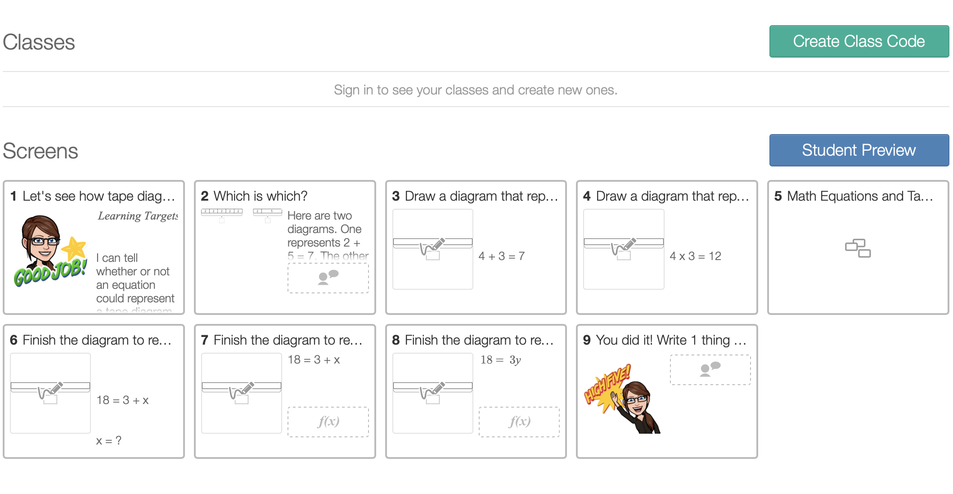 | Rationale:  - It is important to get a feel for what previous knowledge students have or do not have. Most students should be familiar with tape diagrams and this pre-assessment will help reawaken those skills. The warm-up will also show me who needs support with tape diagrams so that they can be successful in the “cool down.”  - Students need to start exploring and working with tape diagrams and applying them to expressions and equations. This learning and new learning is directed to support them in doing well for the end of class assessment of the “cool down” by practicing with tape diagrams and working as a class to form a general understanding of how they relate to equations.  - Similar to whole-class learning, I get to eavesdrop on learning and support learning where ever needed. During this time, I want to make sure everyone is getting prepared for the “cool down” and I have the time to individually work with partner groups who need more support.  - The “cool down” assessment will show me who has gained today’s lesson objectives.

References
California State Board of Education. (2020, March). Content Standards. Retrieved April 26, 2020, from https://www.cde.ca.gov/be/st/ss/
Illustrative Mathematics. (n.d.). Instructional Routines. Retrieved April 26, 2020, from https://curriculum.illustrativemathematics.org/HS/teachers/1/instructional_routines.html
Silver, H. (n.d.). Compare & Contrast. Retrieved April 26, 2020, from http://www.ascd.org/publications/books/110126/chapters/Section-1@-Why-Compare-$-Contrast¢.aspx
Slavin, R. E. (2018). Educational psychology: theory and practice (12th ed.). NY, NY: Pearson.
Teacherspayteachers.com. (n.d.). Solving Equations - Hanger Method Practice. Retrieved May 03, 2020, from https://www.teacherspayteachers.com/Product/Solving-Equations-Hanger-Method-Practice-4324814

